Project 1: Bayesian Network Learning
Wei-Lin Pai, wpai@stanford.edu
- Algorithm Description
In my implementation of the Bayesian network learning, I choose the K2 Search algorithm to find the possible network structure. The reason I choose K2 Search is based on the following reasons:
- It begins with a graph with no directed edges, which is straightforward to implement
- It runs in polynomial time
- Greedily adding parents
However, it cannot guarantee a globally optimal solution, so I iterate K2 Search through different initial ordering. This part is implemented in iterative_K2_fit(), which essentially run K2 Search function K2_fit() multiple times with random initial ordering. The iteration terminates when the iteration times exceed the maximum iteration (max_iter) time or the improvement of the Bayesian score is lower than the improvement threshold (improvement_threshold).
In the K2 search algorithm, the most essential function is calculating the Bayesian score, and here, I use equation 5.5 from the textbook to calculate the Bayesian Score in function Bayesian_score(). Assuming prior equal to 1, the alpha is calculated in compute_a(). Another unknown in the log Bayesian Score function is m, and it is calculated in compute_m(). One thing to notice is that the DataFrame datatype needs to be converted into an Integer Matrix before doing a row broadcast in Julia; the df_to_matrix() achieves this goal.
Pseudo Code for Iterative K2 Search:
Iterative_K2_Search(Data, max_iter, improve_threshold):
s = shuffle_order()
Graph = K2_fit(s,Data)
if(iter > max_iter || improve< improve_threshold):
break
return G_best, Score_best
Below is the Bayesian score and their run time I test for 1, 10, 100 iteration:
B_Score/runtime | 1 iteration | 10 iterations | 100 iterations
small.csv | -3839.05 (0.062s) | -3818.33 (0.152s) | -3801.09 (2.984s)
medium.csv | -96945.66 (1.479s) | -97333.55 (18.31s) | -96652.33 (155.592s)
large.csv | -426687.06 (158.532 s)

I didn’t run an iterative K2 Search for large.csv; this is because it will take too much time; the reason should be that I do not set the upper bound on the number of parents, so the structure becomes complex. However, K2 Search is a greedy algorithm, so a one-time search will have guaranteed output.
Data preprocess include calculating the number of instantiations for each node, and I use max() in each row of DataFrame to find out in construct_vars(). Also, I customize a struct Node with names{String} and r{Int} attributes.
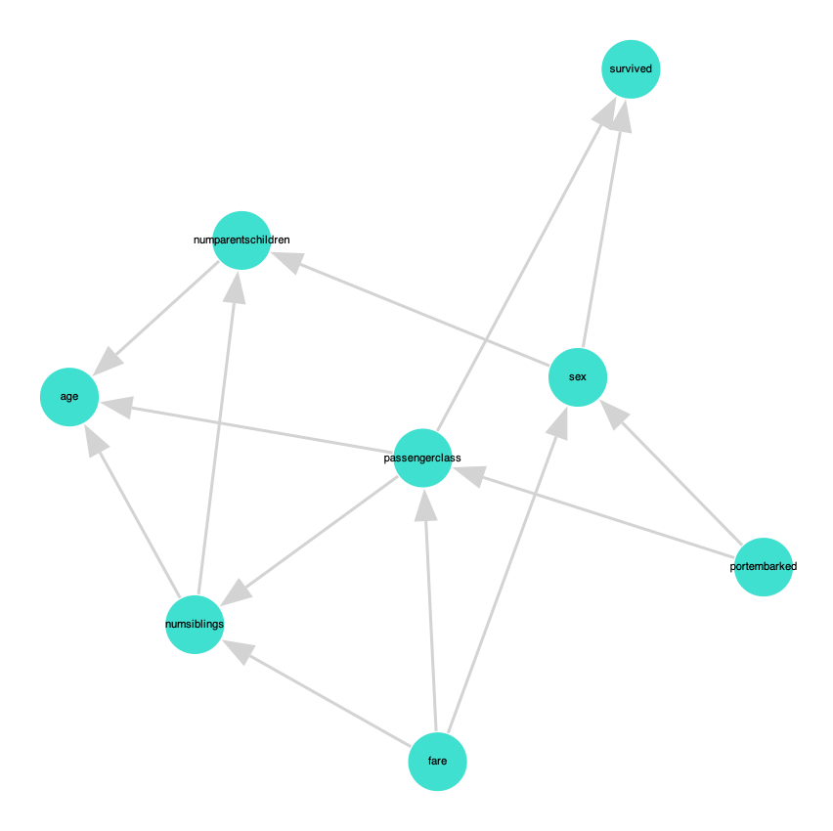
Figure 1. small.gph (1 Iteration)
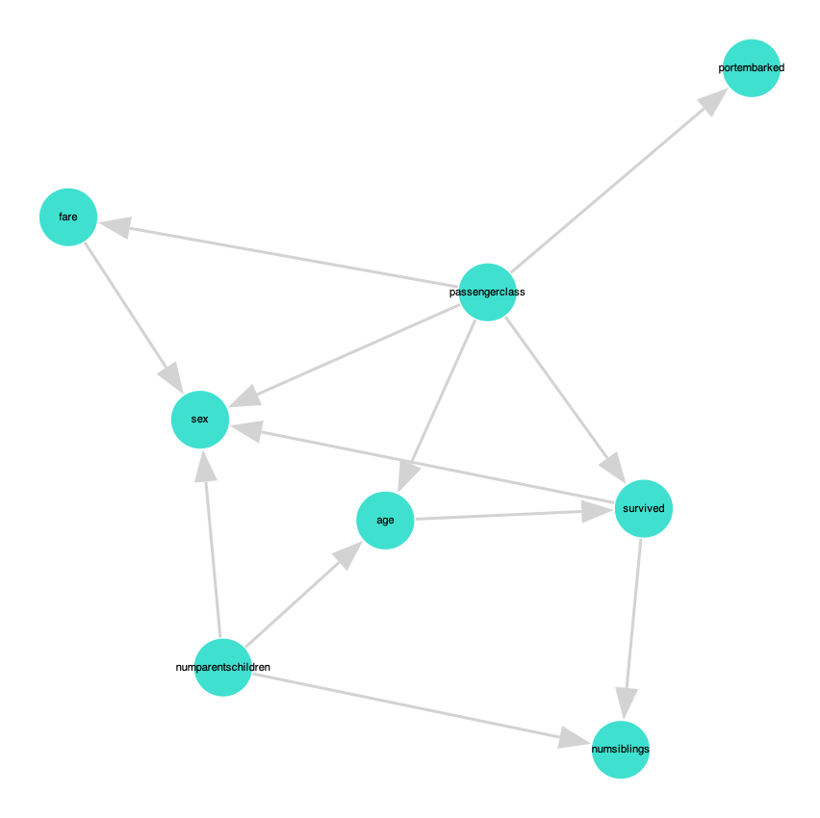
Figure 2. small.gph (10 Iterations)
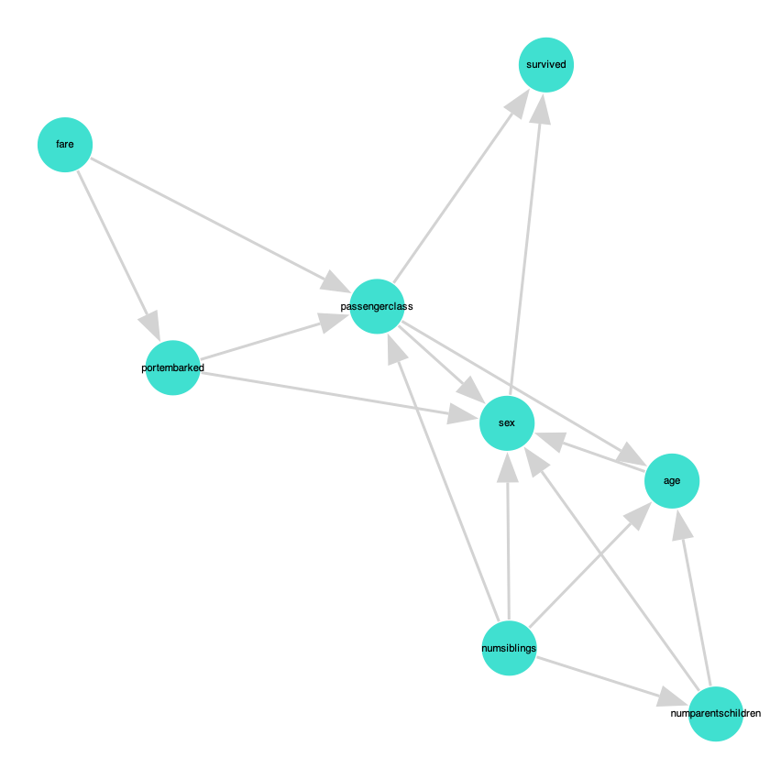
Figure 3. small.gph (100 Iterations)
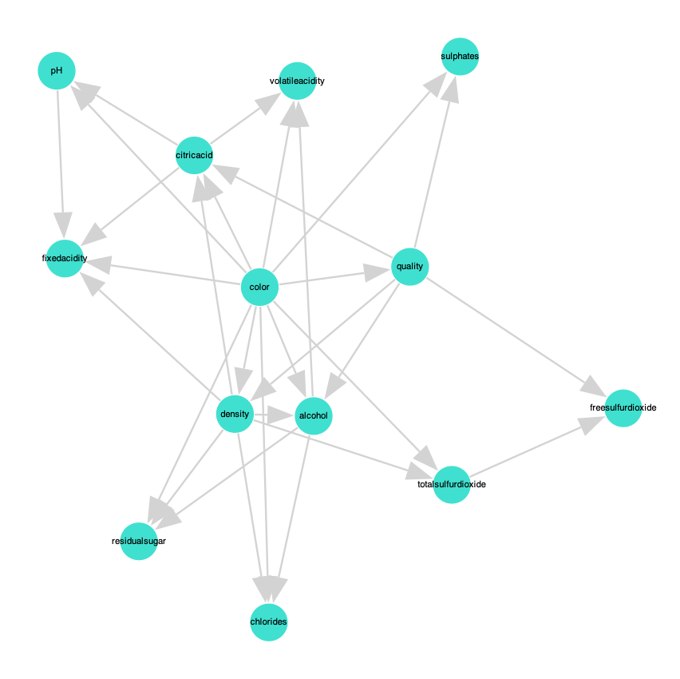
Figure 4. medium.gph (1 Iteration)
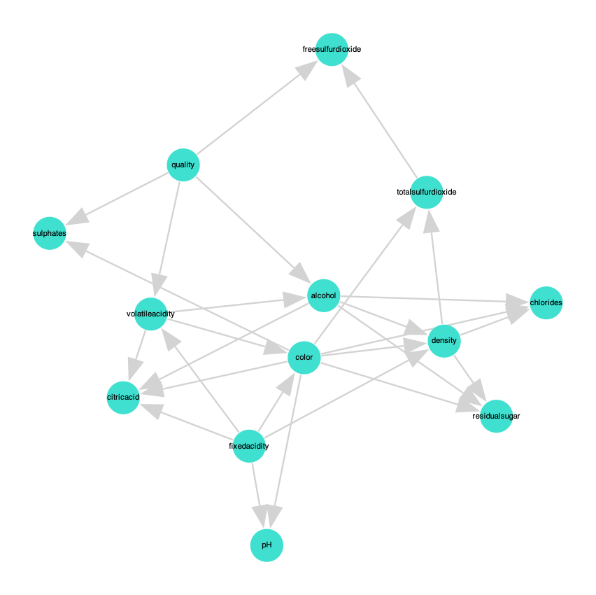
Figure 5. medium.gph (10 Iterations)
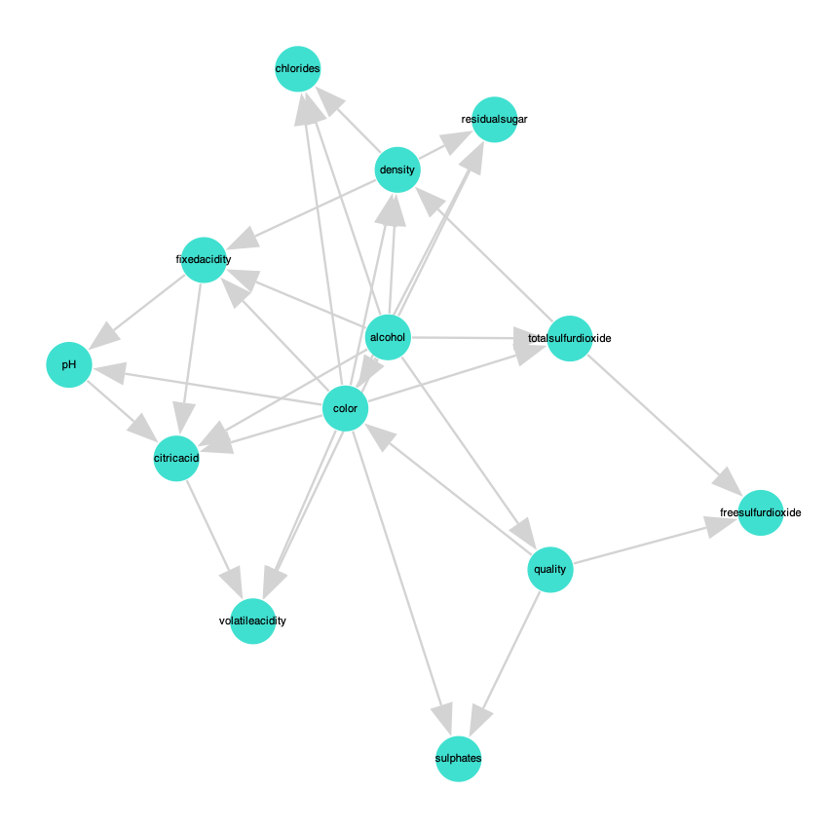
Figure 6. medium.gph (100 Iterations)
Figure 7. large.gph (1 Iteration)
Project.jl
using Printf
using Pkg
Pkg.add("DataFrames")
Pkg.add("CSV")
Pkg.add("Graphs")
Pkg.add("GraphPlot")
Pkg.add("Compose")
Pkg.add("Cairo")
Pkg.add("Fontconfig")
Pkg.add("SpecialFunctions")
using DataFrames
using CSV
using Graphs
using LinearAlgebra
using GraphPlot
using Compose, Cairo, Fontconfig
using Random
using SpecialFunctions
using Profile

mutable struct Node
names::String
r::Int
end

# Establish r for every node
function construct_vars(df)
node_names = names(df)
n = length(node_names)
vars = Node[]
for i in 1:n
r = maximum(df[:,i])
names = node_names[i]
push!(vars,Node(names,r))
end
return vars
end

# Linear Indice
function sub2ind(siz,x)
k = vcat(1,cumprod(siz[1:end-1]))
return dot(k, x .- 1) +1
end

function compute_a(vars,G)
n = length(vars)
# r = # instantiation of X_i
r = [vars[i].r for i in 1:n]
# q = # instantiation of Parent Nodes
q = [prod([r[j] for j in inneighbors(G,i)]) for i in 1:n]
return [ones(q[i],r[i]) for i in 1:n]
end

# Convert DataFrame to Integer Matrix
function df_to_matrix(df::DataFrame)
return Matrix{Int}(df)
end

function compute_m(vars, G, D::DataFrame)
D_matrix = df_to_matrix(D)
return compute_m(vars, G, D_matrix)
end

function compute_m(vars, G, D::Matrix{Int})
n = size(D,2)
r = [vars[i].r for i in 1:n] # r = # instantiation of X_i
q = [prod([r[j] for j in inneighbors(G,i)]) for i in 1:n] # q = # instantiation of Parent Nodes
m = [zeros(q[i],r[i]) for i in 1:n]
for o in eachrow(D)
for i in 1:n
k = o[i]
parents = inneighbors(G,i)
j = 1 # if no parents, assume j = 1
if !isempty(parents)
j = sub2ind(r[parents],o[parents])
end
m[i][j,k] += 1.0
end
end
return m
end

function bayesian_score_component(m,a)
p = sum(loggamma.(m+a))
p -= sum(loggamma.(a))
p += sum(loggamma.(sum(a,dims = 2)))
p -= sum(loggamma.(sum(a,dims = 2)+sum(m,dims=2)))
return p
end

function bayesian_score(vars, G, D::DataFrame)
D_matrix = df_to_matrix(D)
return bayesian_score(vars, G, D_matrix)
end

function bayesian_score(vars,G,D)
n = length(vars)
# Compute statistic
m = compute_m(vars,G,D)
# Compute prior
a = compute_a(vars,G)
return sum(bayesian_score_component(m[i],a[i]) for i in 1:n)
end

struct K2Search
ordering::Vector{Int}
end

function K2_fit(method::K2Search,vars,D)
G = SimpleDiGraph(length(vars))
for (k,i) in enumerate(method.ordering[2:end])
# Calculate bayesian score
y = bayesian_score(vars,G,D)
while true
y_best, j_best = -Inf, 0
for j in method.ordering[1:k]
# Try add adge
if !has_edge(G,j,i)
add_edge!(G,j,i)
y_h = bayesian_score(vars,G,D)
if y_h > y_best
y_best,j_best = y_h,j
end
rem_edge!(G,j,i)
end
end
if y_best > y
y = y_best
add_edge!(G,j_best,i)
else
break
end
end
end
return G
end

function iterative_K2_fit(vars,D,max_iter,improvement_threshold)
# Set up initial G, score
best_G = nothing
best_score = -Inf

for iter in 1: max_iter
# Shuffle random order for search
order = shuffle(1:length(vars))
method = K2Search(order)
G = K2_fit(method,vars,D)
b_score = bayesian_score(vars,G,D)

if b_score > best_score
# Break if improve is slow
if (iter > 1 && (b_score-best_score)/abs(best_score) < improvement_threshold)
best_score = b_score
best_G = G
println("Iter"*string(iter)*": "*string(best_score))
break
end
best_score = b_score
best_G = G
println("Iter"*string(iter)*": "*string(best_score))
end
end
return best_G, best_score
end

"""
write_gph(dag::DiGraph, idx2names, filename)

Takes a DiGraph, a Dict of index to names and a output filename to write the graph in `gph` format.
"""
function write_gph(dag::DiGraph, idx2names, filename)
open(filename, "w") do io
for edge in edges(dag)
@printf(io, "%s,%s\n", idx2names[src(edge)], idx2names[dst(edge)])
end
end
end

function compute(infile, outfile)

# Set timer
total_time = @elapsed begin
# Read CSV
df = CSV.read(infile,DataFrame)
# Setup vars
vars = construct_vars(df)
# set up idx to name
idx2names = Dict(i => vars[i].names for i in 1:length(vars))
# Set up timer for iterative K2 Search
learning_time = @elapsed begin
# iterative K2 Search
G,score = iterative_K2_fit(vars,df,1,0.0001)
end
# Plot graph
node_labels = [idx2names[i] for i in 1:nv(G)]
p = gplot(G; nodelabel=node_labels, NODELABELSIZE=10.0,layout=spring_layout)
draw(PDF(string(outfile)*".pdf", 100cm, 100cm), p)
# Write gph
write_gph(G,idx2names,outfile)
end
println("Final Score: "*string(score))
println("Structure learning time: $(round(learning_time, digits=3)) seconds")
println("Total runtime: $(round(total_time, digits=3)) seconds")

end

function main()
if length(ARGS) != 2
error("usage: julia project1.jl <infile>.csv <outfile>.gph")
end

inputfilename = ARGS[1]
outputfilename = ARGS[2]

compute(inputfilename, outputfilename)
end

main()
# @profile main()
# Profile.print()

